JAVA MEDIUM PROGRAMS

1.PROGRAM TO COUNT ALL PRIME AND COMPOSITE NUMBERS. 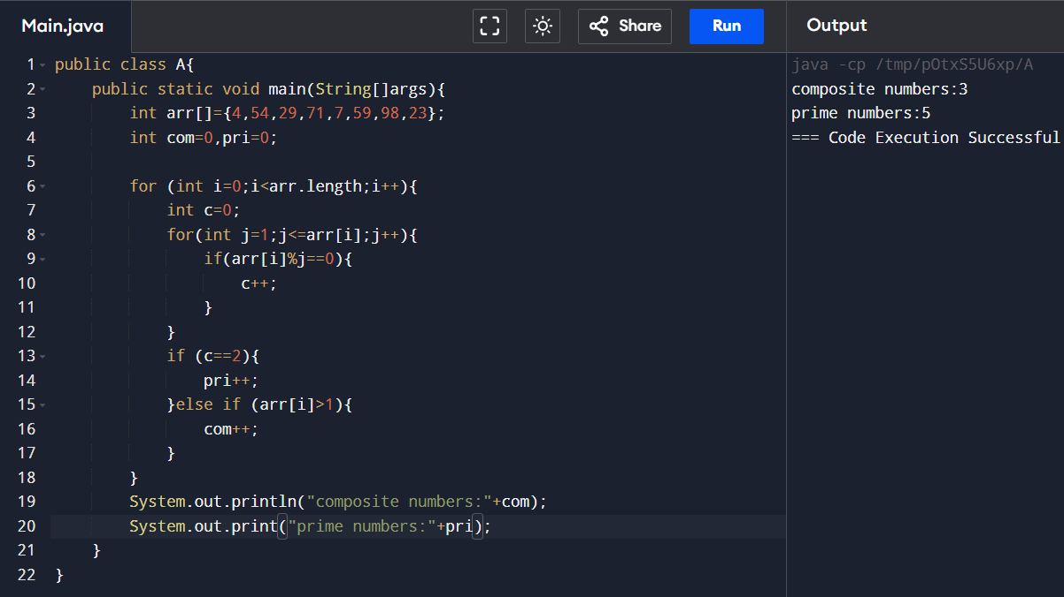

2.FIND Mth MAXIMUM NUMBER AND Nth MINIMUM NUMBER IN AN ARRAY. 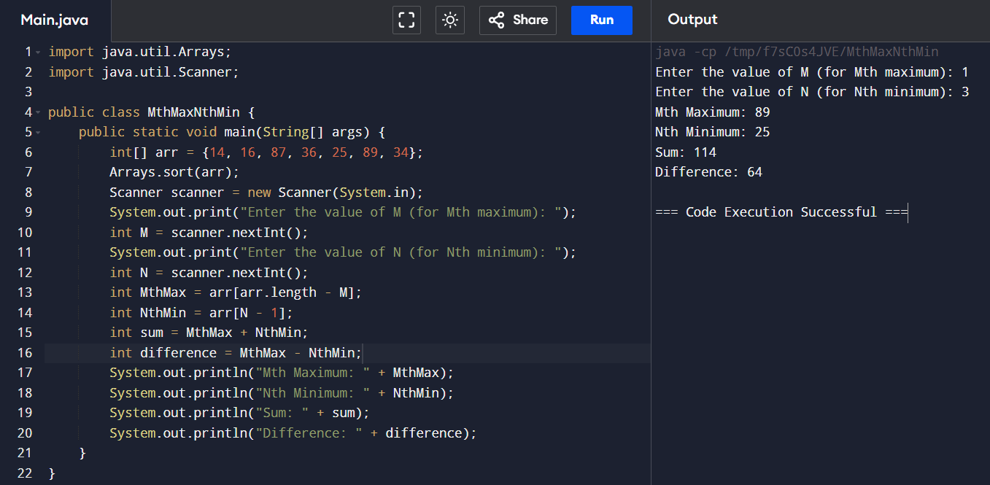

3.TOTAL AMOUNT AVAILABLE IN ATM MACHINE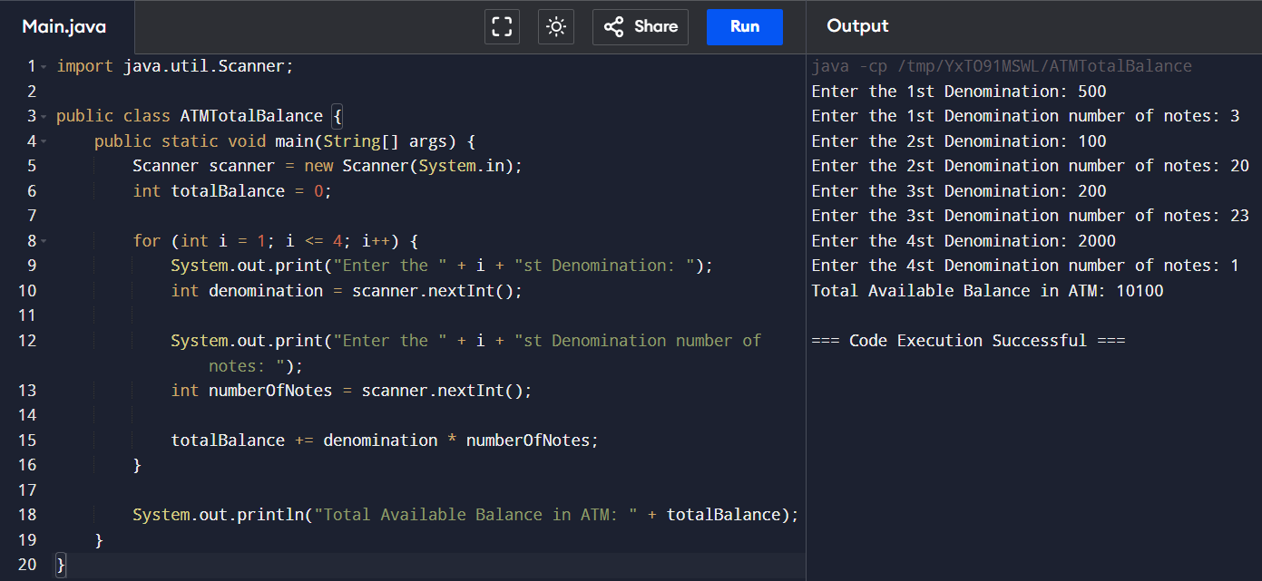

4.PROGRAM TO CHECK PALLINDROME OR NOT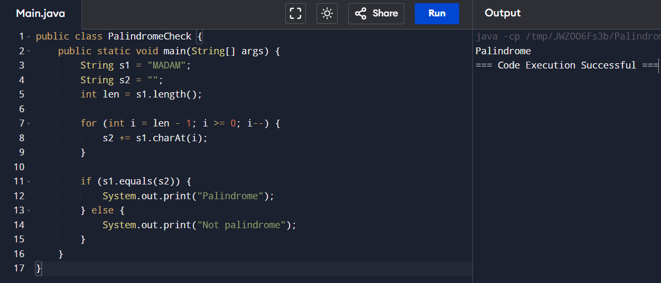

5.PROGRAM TO CONVERT DECIMAL NUMBER TO BINARY AND OCTAL NUMBER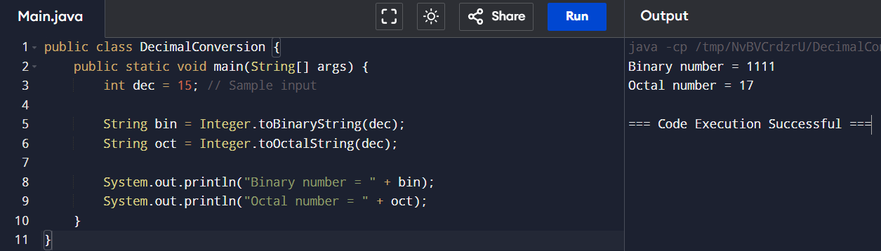

6.CALCULATE THE BONUS AND PRINT THE SALARY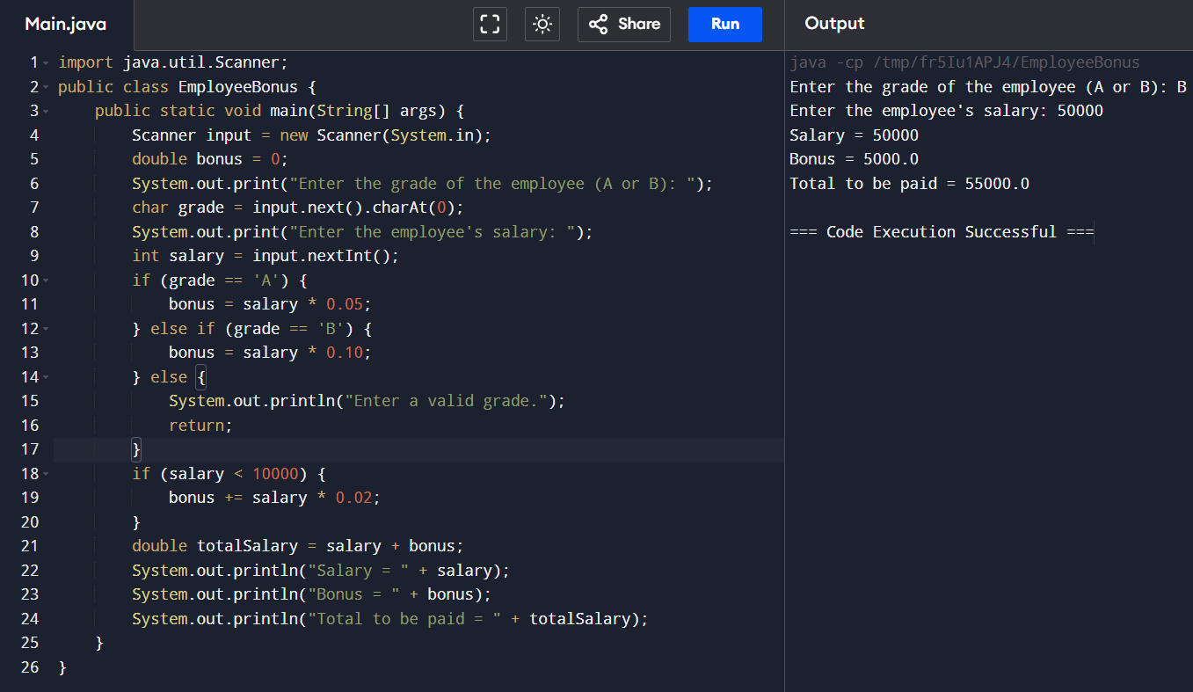

7.PRINT THE FIRST N PERFECT NUMBERS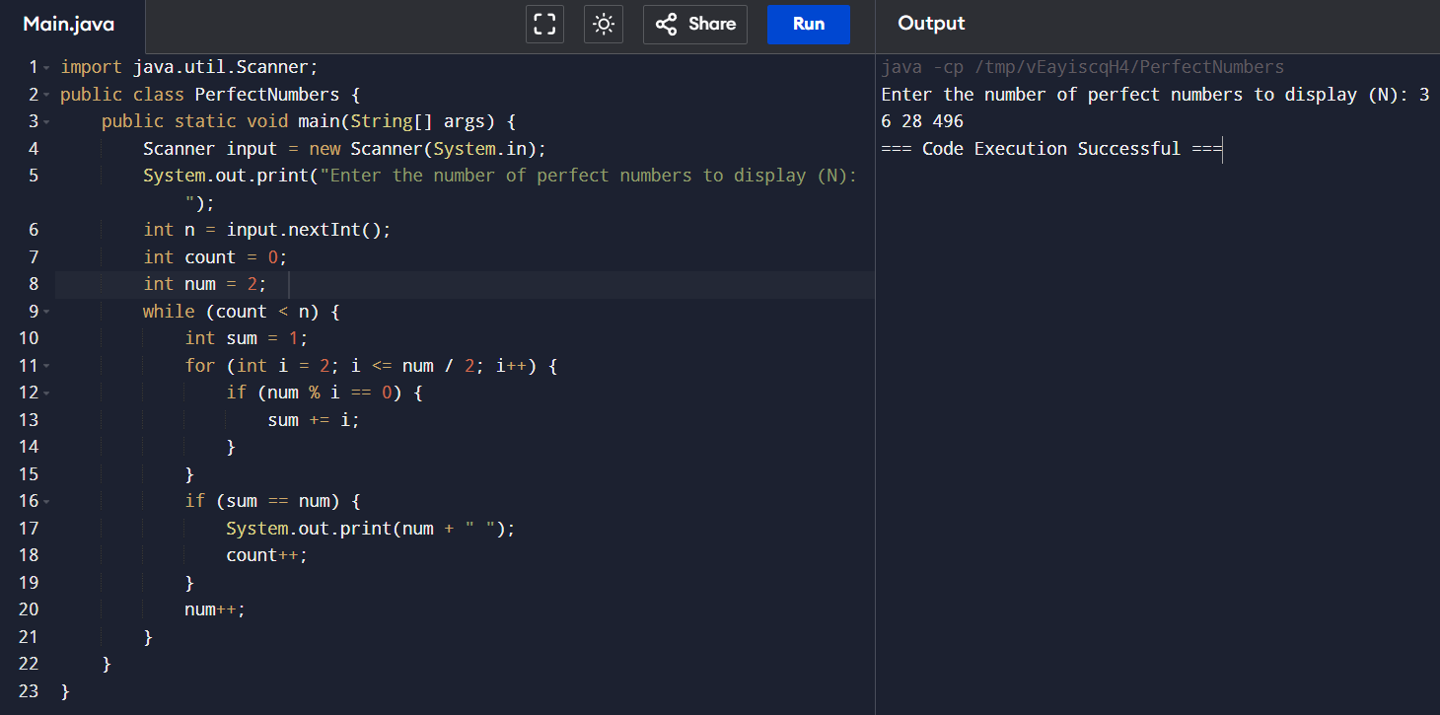

9.PROGRAM FOR MARK OF THE STUDENTS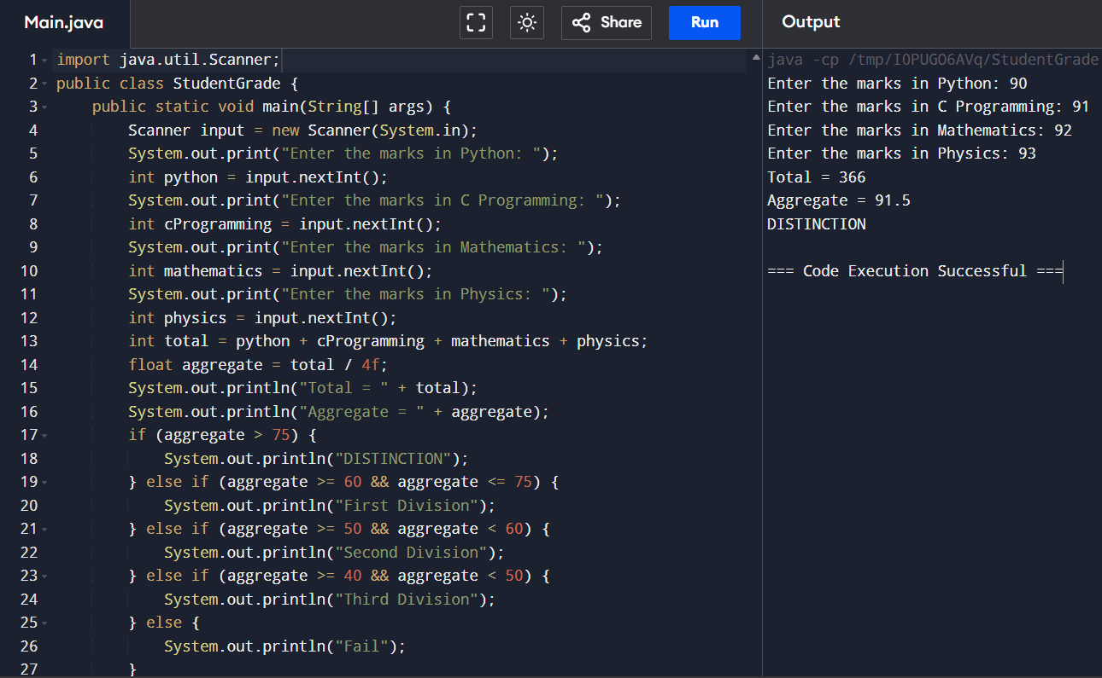

10.PROGRAM TO CALCULATE TAX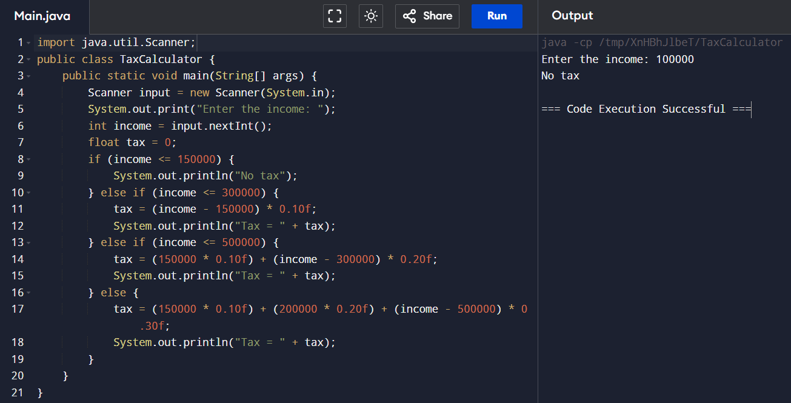

11.FIND MARK OF THE STUDENTS AND CALCULATE TOTAL AND AGGREGATE

SAME AS 9TH PROGRAM

12.MULTIPLICATION TABLE 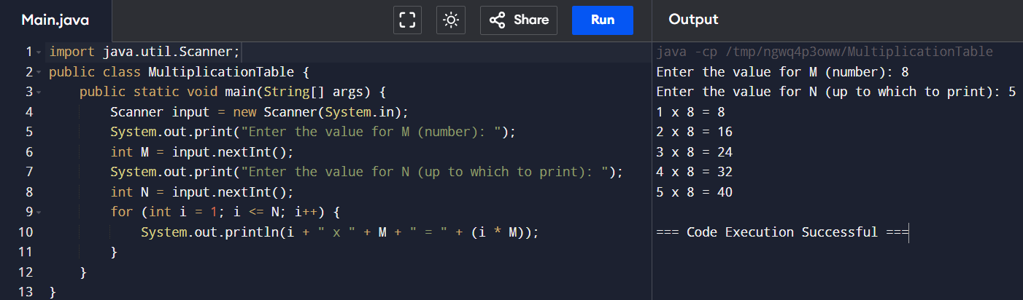

13.READ THE NUMBER UNTIL -1 IS ENCOUNTERED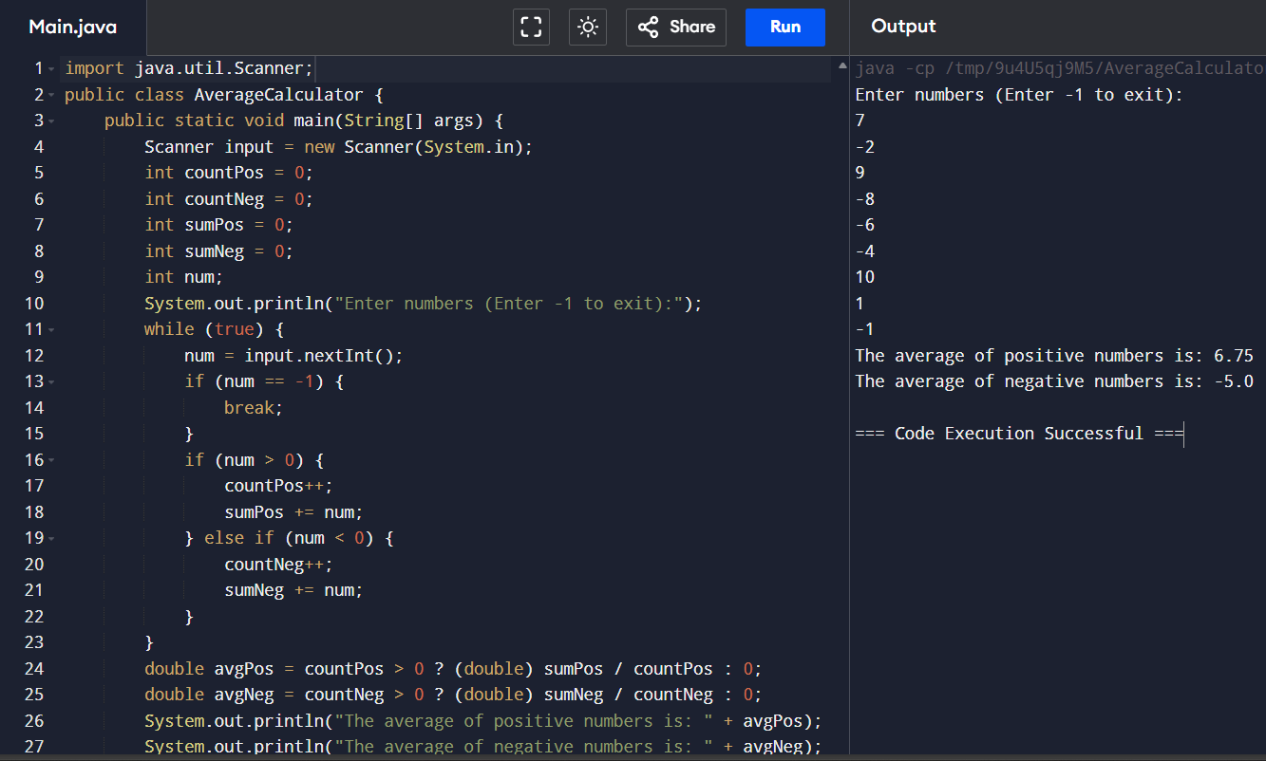

14.READ A CHARACTER UNTIL a\* IS ENCOUNTERED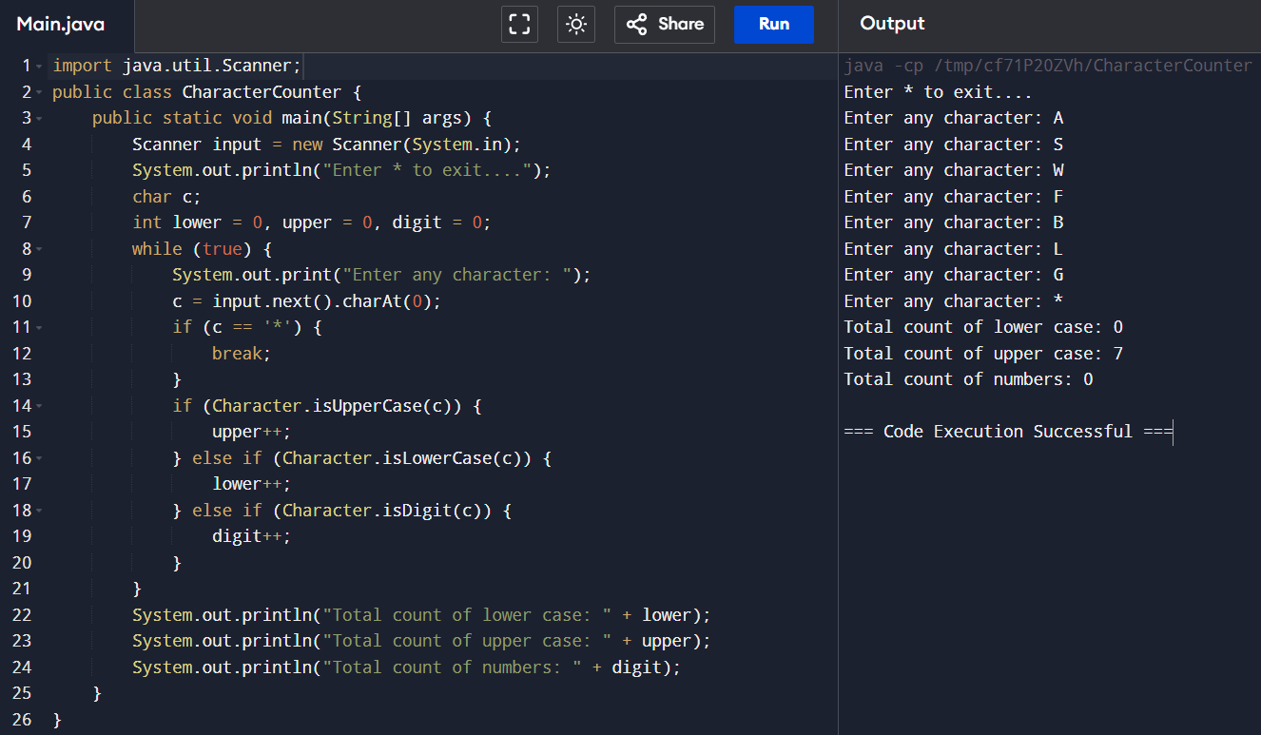

15.CALCULATE THE FACTORIAL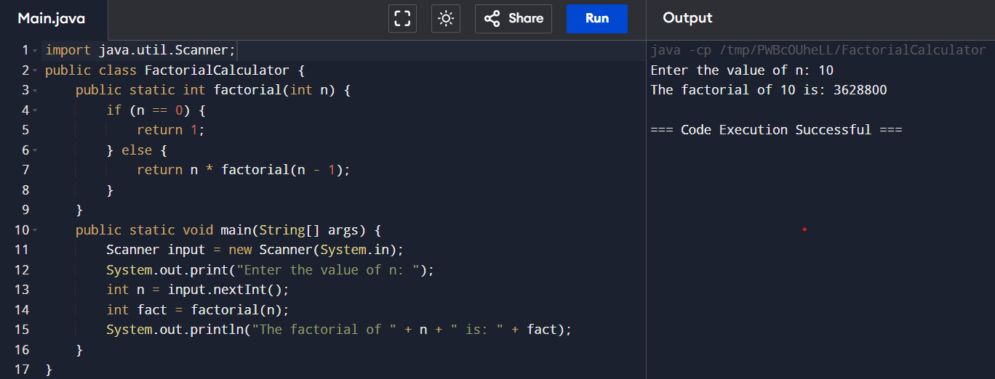

16.FIND THE Nth LARGEST NUMBER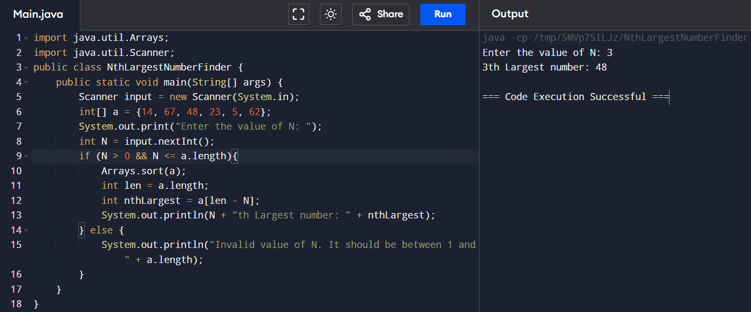

17.CONVERT BINARY TO DECIMAL,OCTAL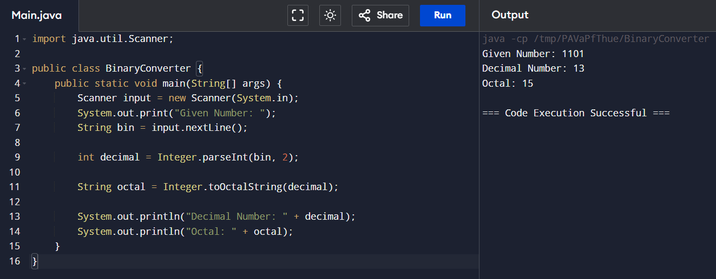

18.FIND THE NUMBER OF SPECIAL CHARACTER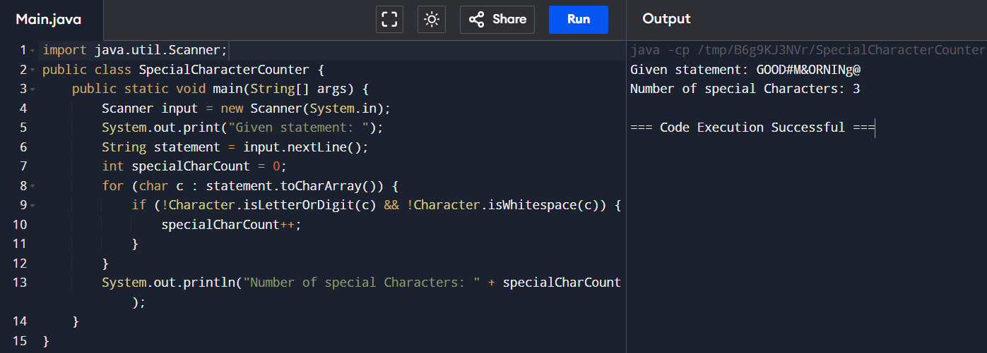

19.REMOVE THE DUPLICATE ITEMS FROM AN ARRAY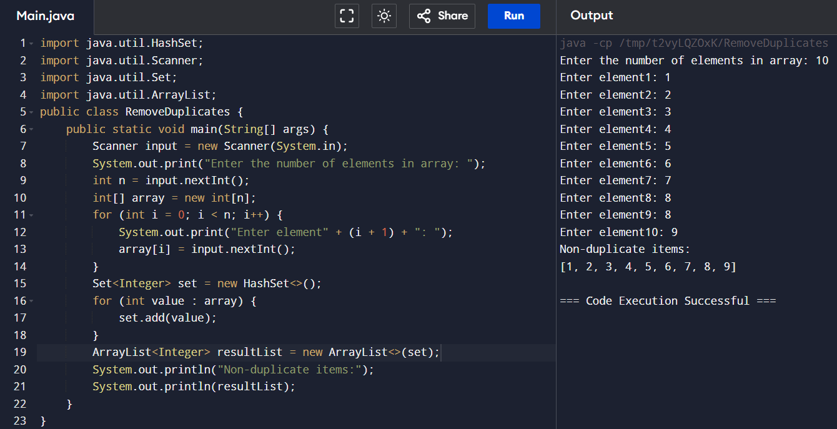

20.CALCULATE SIMPLE INTREST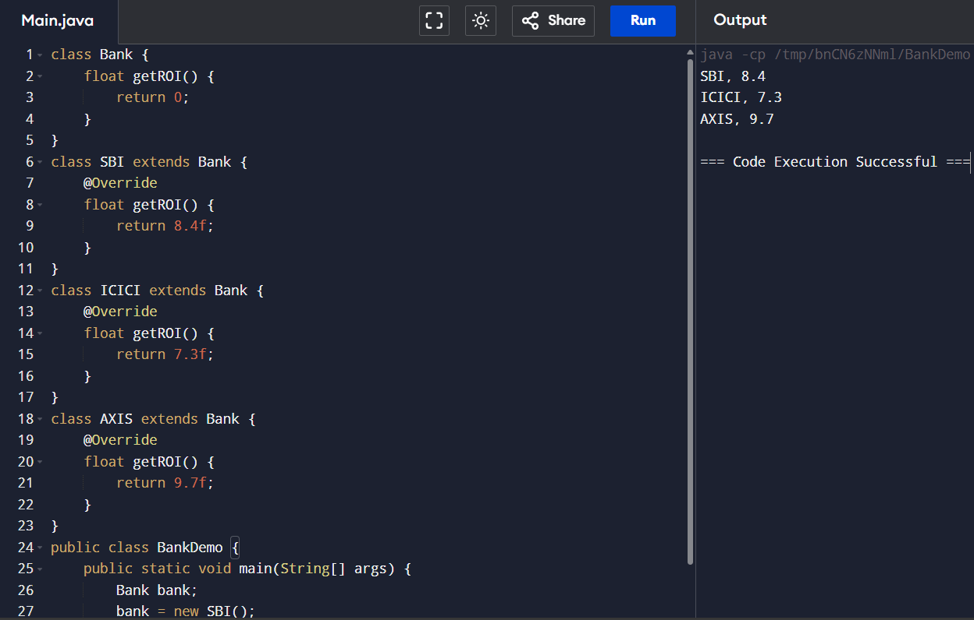

21.DISPLAY THE INPUT VALUES PROVIDES THROUGH CLASS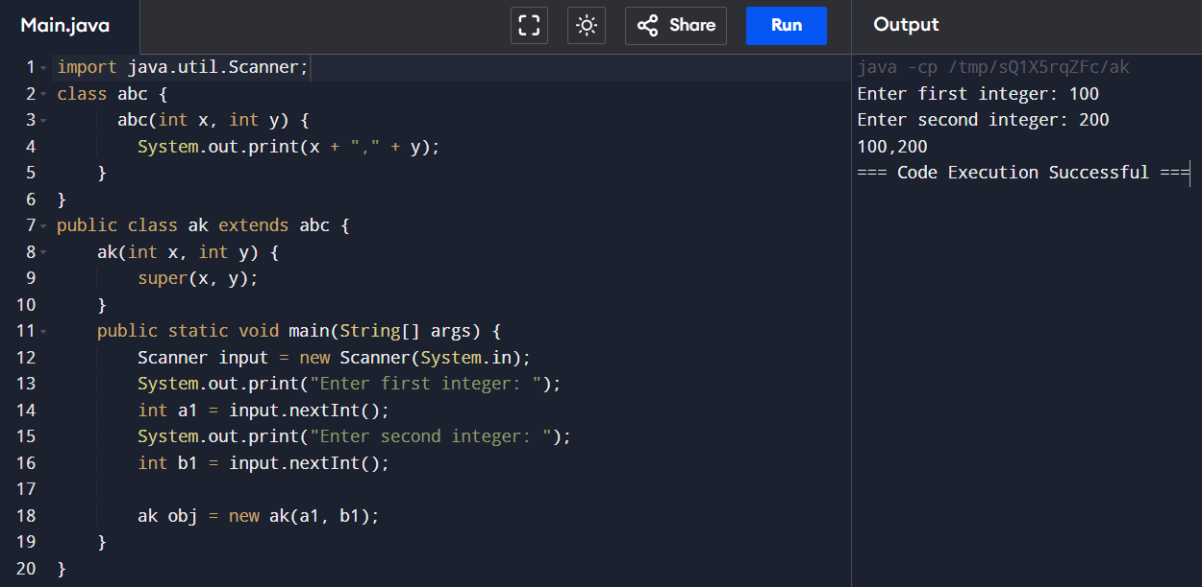

22.MULTIPLICATION TABLE FOR 5 AND 10 USING VARIOUS STAGES

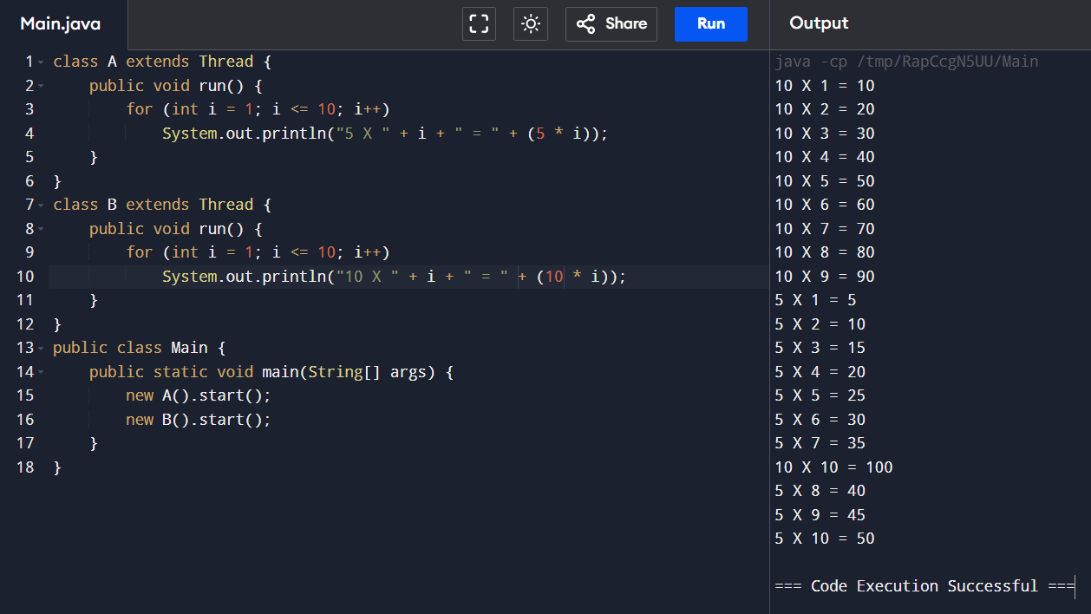

23.FIBONACCI SERIES

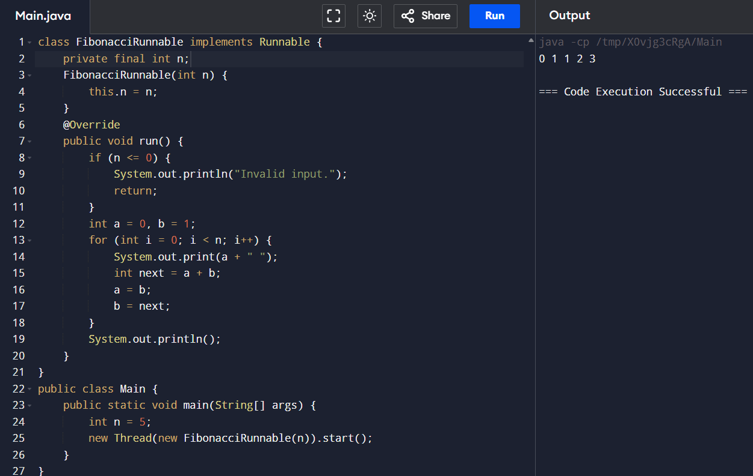

24.FIND THE SUM OF N NUMBERS USING ARRAY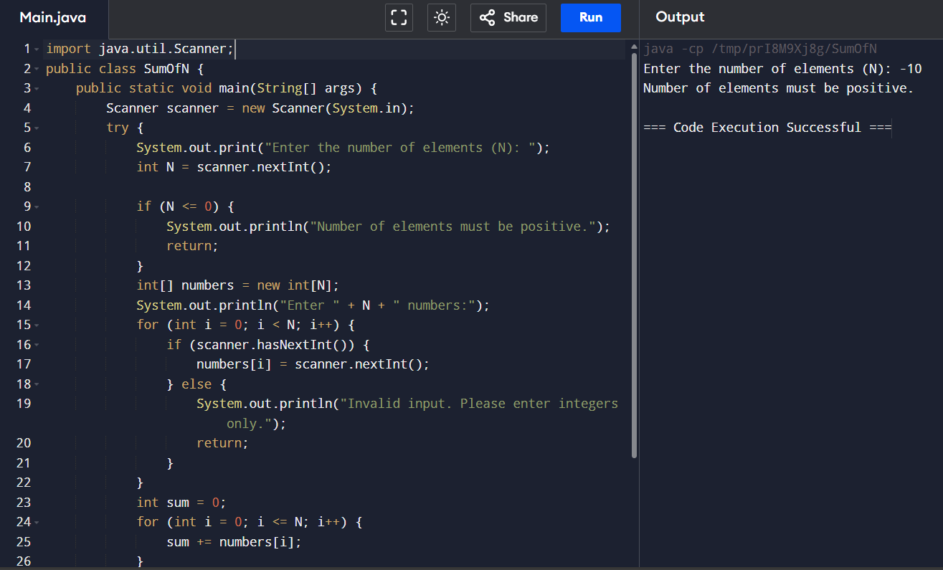

25.using the concepts of thread with implementing Runnable interface to find the no is prime or not. 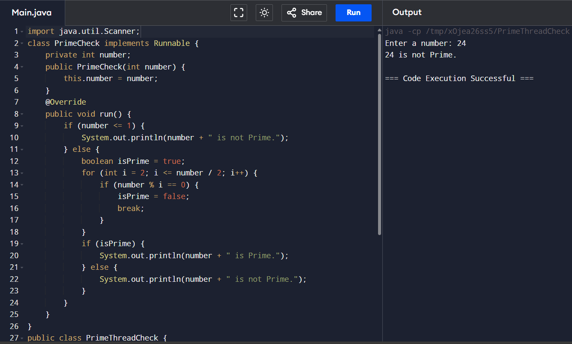

26. Given a string s consisting of words and spaces, return the length of the last word

in the string. A word is a maximal substring consisting of non-space characters only.

There will be at least one word, consists of only English letters and spaces ' '.

